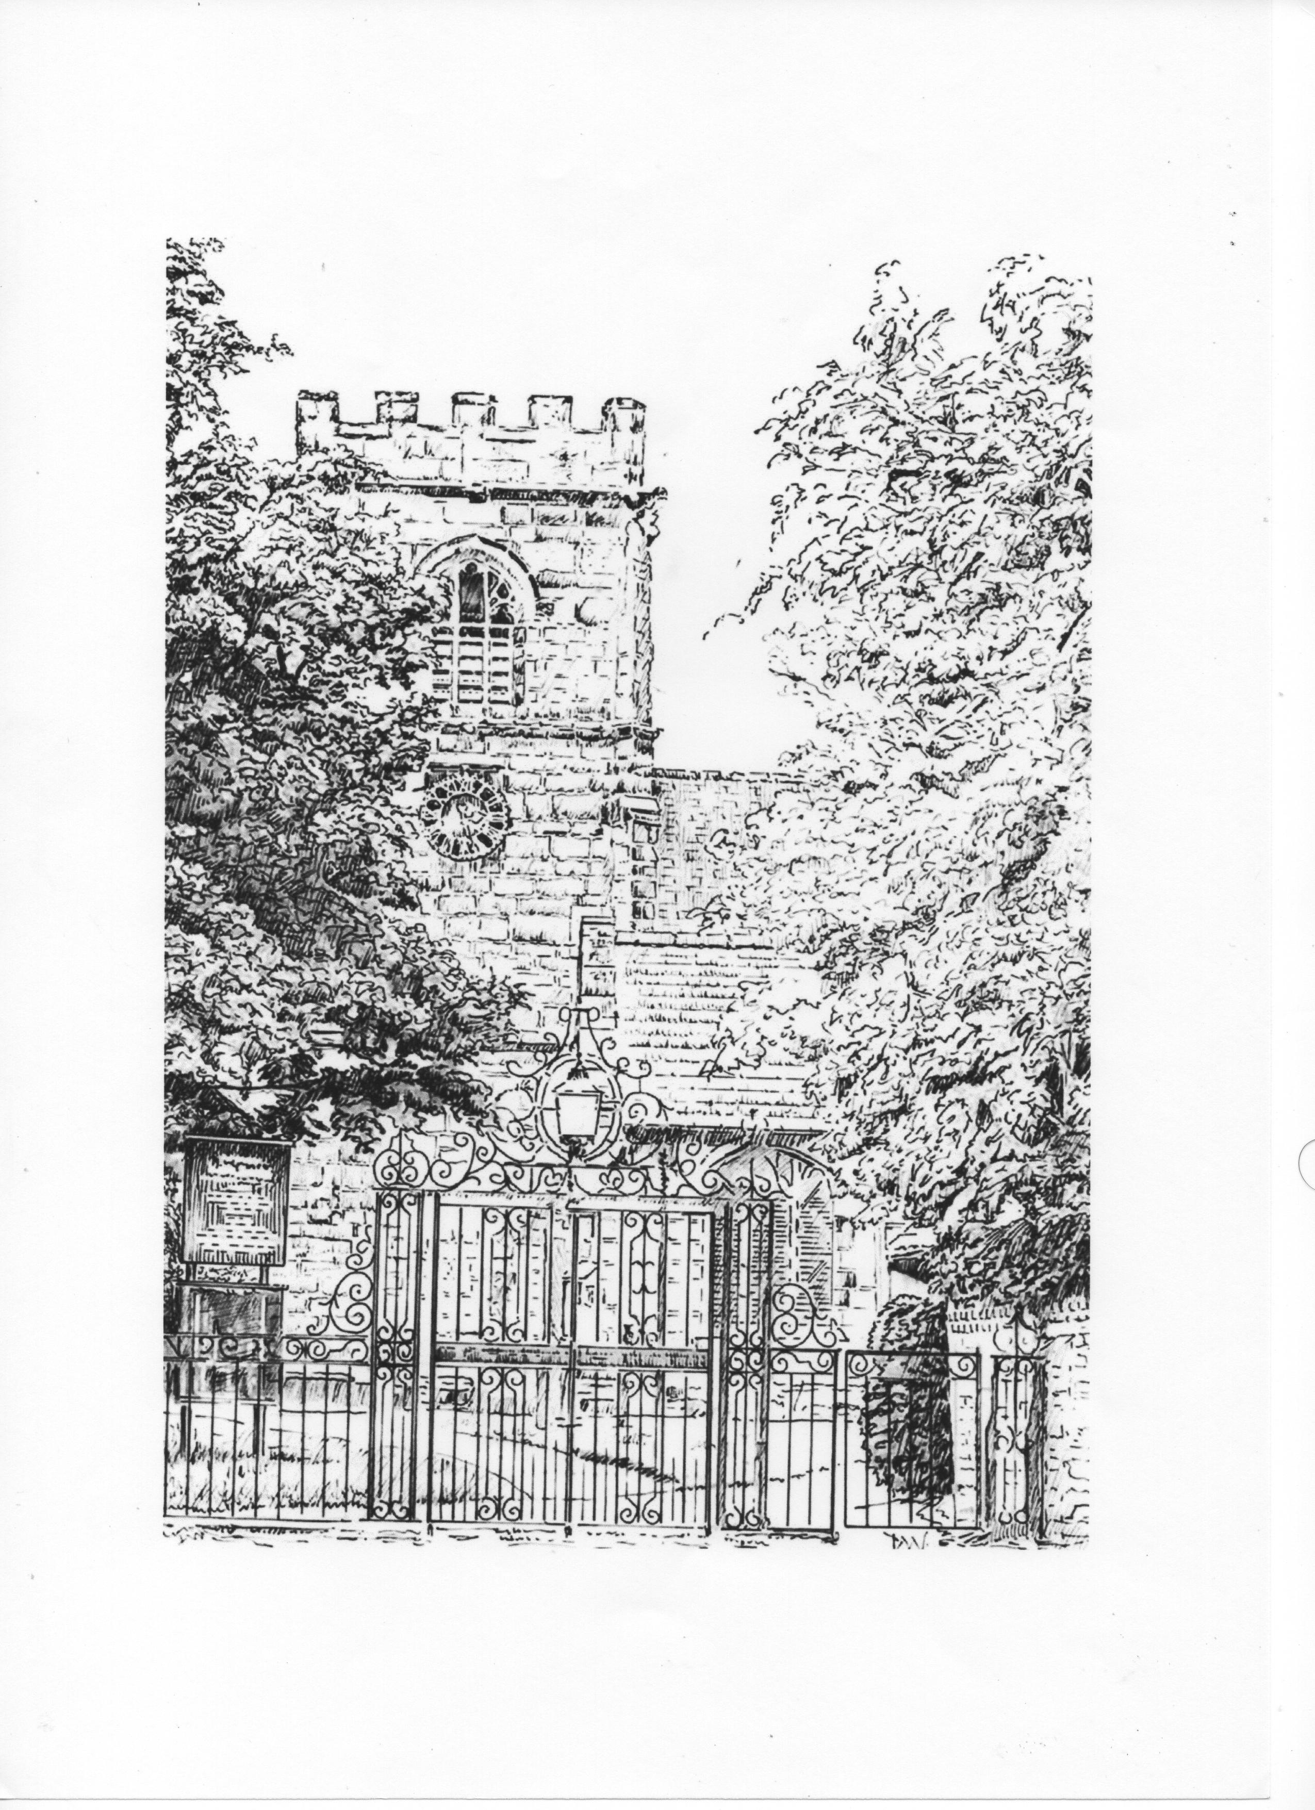ST. ALBAN’S CHURCH, TATTENHALL
www.tattenhallchurch.co.uk

APPLICATION FOR BAPTISM
Notice of at least 2 weeks should be given
before a child is brought to the church for baptism

Please complete in BLOCK CAPITALS within the boxes.

Child / Candidate
Christian name(s) and surname | Date of Birth
Address | Contact ‘phone number

Parents | Baptised? Y/N | Confirmed? Y/N | Occupation
Father’s full name

Mother’s full name

Address & ‘phone number if different from above

Godparents | Baptised? Y/N | Confirmed? Y/N
Godparent name

Godparent name

Godparent name

Day of Baptism Service
Preferred date(s) for Baptism | Baptism Hymn (Only if Baptism is at 10:30am Sunday service)
Approx number of expected guests | Do you require further details on font flowers?  Delete as applicable YES / NO

Important:- please read notes overleaf

Please complete and save this file (preferably with your name in the filename)
and e-mail to Father Lameck Mutete at lameckmutete@yahoo.co.uk
or print out, complete form in pen and post to the Rectory.

Notes concerning Church Baptism

As a parent or godparent you should ask yourself:
- Are you prepared to the best of your ability to give the child a Christian upbringing within the family of Christ’s church?
- Will you help the child to be regular in public worship and in prayer, not only by your teaching but also by your example and your prayers?
- Will you encourage the child in due time to come to Confirmation and Communion?

It is not essential for parents to be baptised and confirmed unless they are to be godparents.
Church Law requires that godparents should be baptised and confirmed, but the requirement of confirmation can be relaxed.

The usual time for baptism is at the 10:30am service on Sunday morning – preferably on the 1st or 3rd Sunday of the month or on a Saturday by special arrangement.

Please return this form to the Rector at least two weeks before the day of baptism.

Whilst there is not a charge for Baptism, we would very much appreciate a contribution towards the running costs of our church. If you would like to give a donation (in an envelope please), please pass to the churchwardens on the Baptism day.

Our flower guild volunteers are happy to arrange flowers for the font for a small fee. Please indicate if you would like further details.

We look forward to meeting you!

